Changes in Dhara :-
- For GM Login ID
  - Intake Meter Survey :
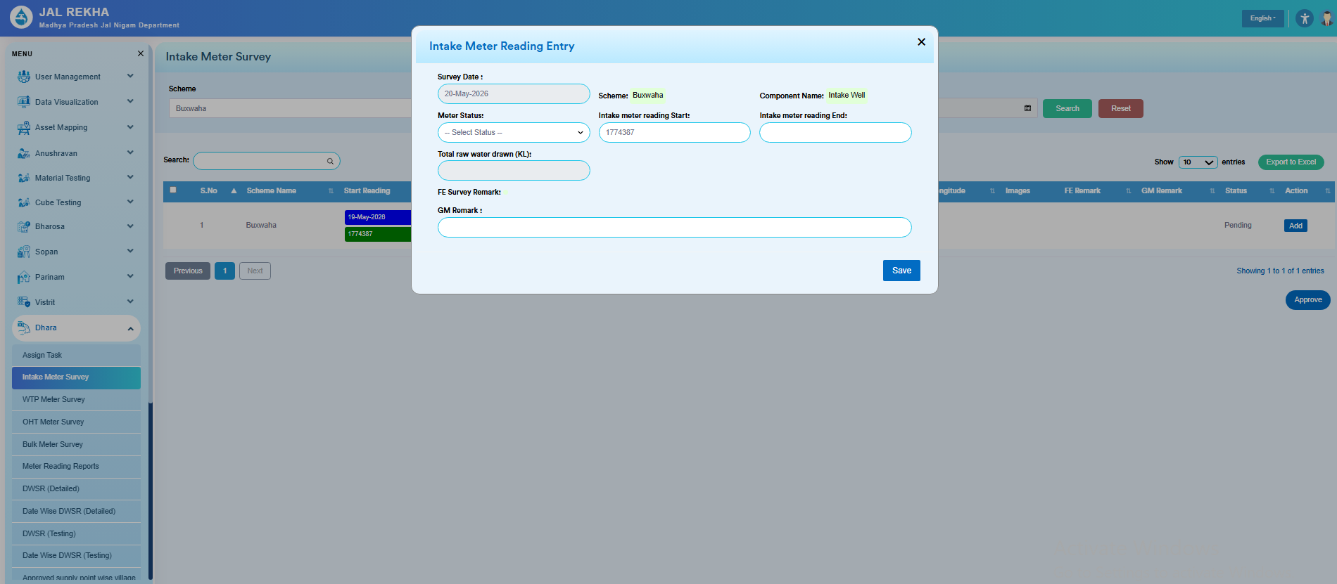

New Sequence:
- Survey Date
- Scheme
- Component Name
- Meter Status
- Intake meter reading start
- Intake meter reading end
- Total raw water drawn (Kl)
- FE Survey Remark
- GM Remark

  - WTP Meter Survey
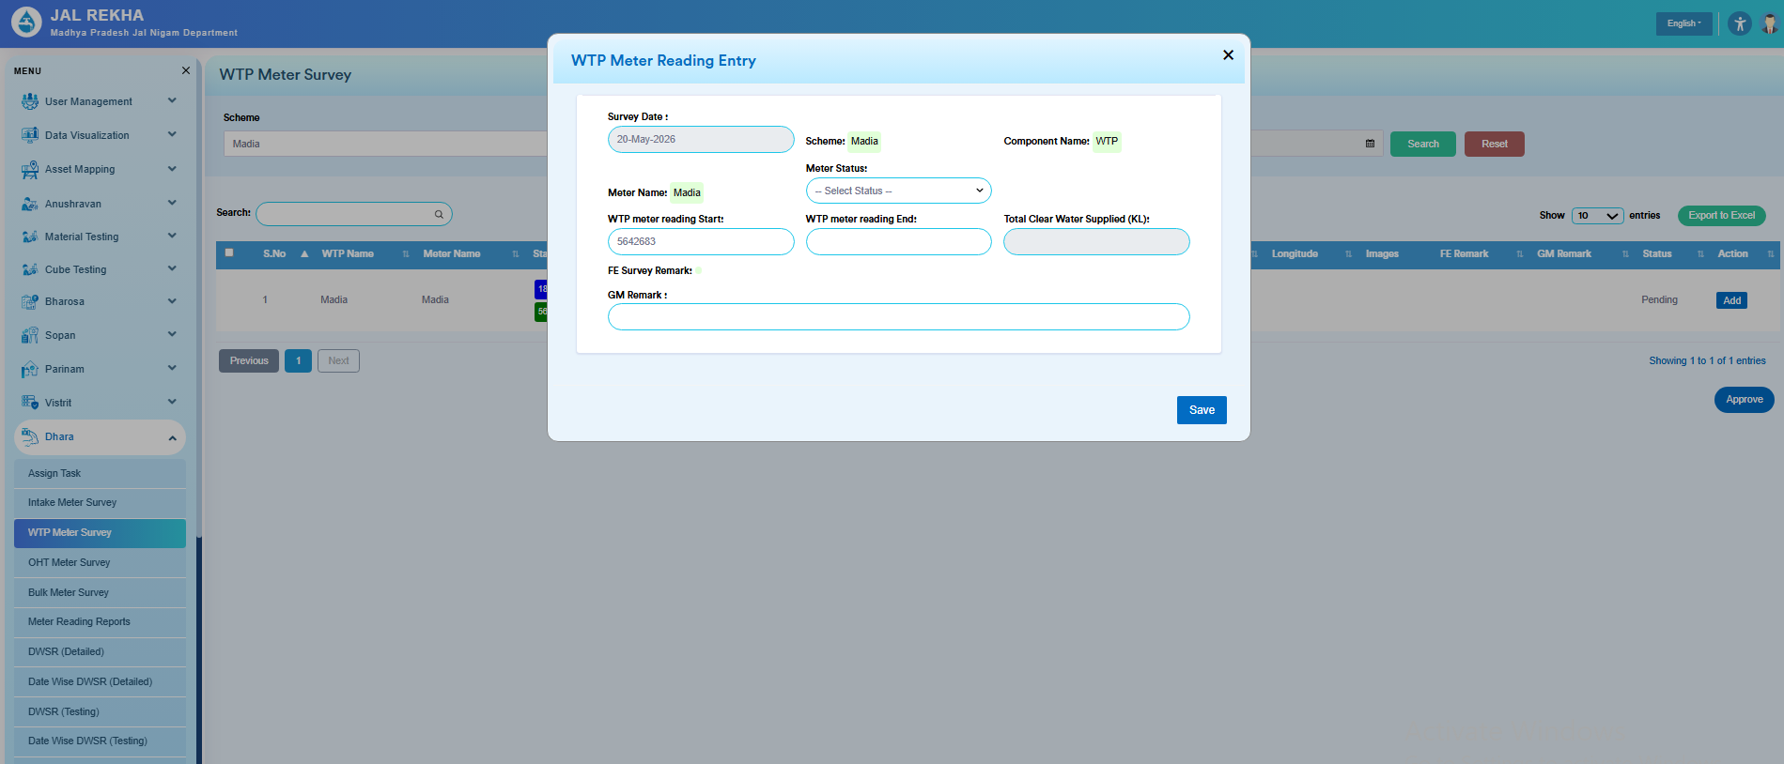
New Sequence:
    - Survey Date
    - Scheme
    - Component Name
    - Meter Name
    - Meter Status ( If Meter Non Functional then Start & End reading should be disable)
    - WTP meter reading Start
    - WTP meter reading End
    - Total Clear Water Supplied (KL)
    - FE Survey Remark
    - GM Remark

  - OHT Meter Survey Change to OHT - WTP | Village Meter Survey
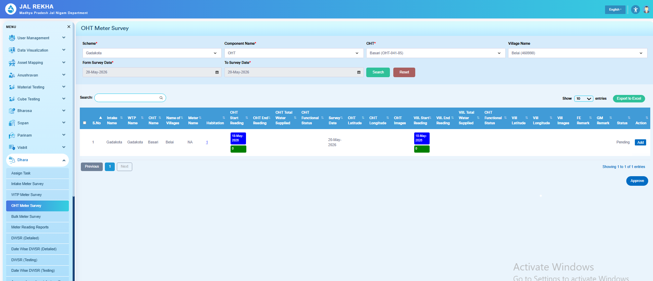
New Sequence:
- Survey Date
- Scheme
- Component Name
- Name of OHT
- OHT Meter Status
- OHT Meter Reading Start
- OHT Meter Reading End
- Total Clear Water Filled (KL)
- Name of Village
- Name of Habitation
- Local Name ( New Column Addition)
- Village Meter Status
- Village Meter Reading Start
- Village Meter Reading End
- Total Clear water supplied in village (KL)
- FE Survey Remark
- GM Remark

NOTE Change : On all Forms – IS Objection ? IS Approved ? or Any Concern – Contractor Remark or Upload Document View.

- All Reports to be shown on all Jal Rekha logins and New Dhara Report – DWSR Detailed Report will be visible on Dashboard.

- Dhara CR Reports - MWSR, DWSR, UFW) - Update, Recreate and fetch – DWSR, MWSR, Bulk Consumer Approved Reports, and UFW
- Dhara CR Reports - Bulk Meter Consumer Reading Survey Form
  - Bulk consumer addition and mapping separately, where the supply point local name and for a village, where each supply point for each local name under a single village needs to be shown properly on the mobile view app for a single beneficiary, and entry by a single beneficiary for all supply points and shown on mobile view in list format

- Dhara CR – GM PIU /TL –
  - Intake meter reading survey changes
    - The total raw water KL measuring unit can only be in editable mode.
But the meter start and end readings should freeze at GM login after FE entry is complete for Non functional meter and replacable meter
  - Meter reading survey for Intake, WTP, OHT, Bulk both for web and mobile (GM Approved Reports and Dispute of DWSR issue - Contractor objection on DWSR entry and FE incorrect entry) where Contractor raise concern.
    - FE entry of meter reading goes to Dhara GM, then GM approves it, then contractor has a window of 3 days to raise concern on meter reading, then again, GM has the right to approve or keep it on hold. If 3 days pass without any action, then it gets auto-approved. If a concern is raised by the contractor, then it will remain open unless & until the GM finally approves
    - Condition 1: FE has a window of 5 days to do entry, where in this window of 5 days, 3 days are open for GM and the contractor to take action and raise concerns, respectively.
    - Condition 2: After FE entry, if GM doesn't approve it for the next 3 days, then it is automatically approved for the contractor.
    - Condition 3: After FE entry, if GM approves the meter reading in a given window of 3 days, then
        - If GM approves on the 1st day itself, then the contractor can agree or raise a concern and again go to GM for final approval, or if not approved, then it gets auto approval.
        - If GM approves on the last day, then the contractor can agree or raise a concern, and it goes to GM. If still GM doesn't approve it, then it will finally get auto-approved within the next 3-day window of GM (means GM 3 day window to approve/hold/or no response.
Note: This complete flow will be visible to all logins, but the window of editing will be for a particular number of days for a particular role login only.
- Dhara GM PIU User CR - Dhara WTP Meter Reading Issue Resolution
- O&M Billing CR Contractor - Updation and Validation Addition in Dhara Reports
Sahbhagita payment – ISA track activity & pass payment
CR manager approve

